**Road Network Identification from Aerial Imagery**

**By**

**Name University Roll Number**

Isha Bhattacharya 12200217046

Swati Roy 12200117009

Akshay Chatterjee 12200117061

**Under the esteemed guidance of**

**Dr. Amit Paul**



**Project Report**

Submitted in the partial fulfilment of the requirement for the degree of

B. Tech in Computer Science and Engineering

**Affiliated to**



**Maulana Abul Kalam Azad University of Technology, West Bengal**

**July, 2021**

**St. Thomas’ College of Engineering and Technology**

**Department of Computer Science and Engineering**

**This is to certify that the work in preparing the project entitled “Road Network Identification from Aerial Imagery” has been carried out by Isha Bhattacharya, Swati Roy and Akshay Chatterjee under my guidance during the session 2020-2021 and accepted in partial fulfilment of the requirement for the degree of B. Tech in Computer Science and Engineering.**

__________________

**Dr. Amit Paul**

**Mentor**

**Department of Computer Science and Engineering St. Thomas’ College of Engineering & Technology,**

**Kolkata,**

**West Bengal, India**

**St. Thomas’ College of Engineering and Technology**

**Department of Computer Science and Engineering**

**DECLARATION**

We declare that this written submission represents our ideas in our own words and we have adequately cited and referenced the original sources. We also declare that we have adhered to all the principles of academic honesty and integrity and have not misrepresented or fabricated or falsified any idea/data/fact/source in our submission. We understand that any violation of the above will be cause for disciplinary action by the Institute and can also evoke penal action from the sources which have thus not been properly cited or from whom proper permission has not been taken when needed.

­­________________ ________________ ________________

**Isha Bhattacharya Swati Roy Akshay Chatterjee**

**Roll: Roll: Roll:**

**Index**

**Preamble**............................................................................................................................................................. **i**

Vision and Mission........................................................................................................................................i

Vision of the Institute..............................................................................................................................i

Mission of the Institute.......................................................................................................................... i

Vision of the Department........................................................................................................................i

Mission of the Department......................................................................................................................i

Program Outcome (PO) and Program Specific Outcome (PSO)...................................................................i

Program Outcomes (POs)...................................................................................................................... i

Program Specific Outcomes (PSOs)...................................................................................................... ii

PO-PSO matrix.............................................................................................................................................ii

**Abstract**............................................................................................................................................................. **iv**

**1. Introduction**................................................................................................................................................... **1**

1.1. Objective of the Project......................................................................................................................... 1

1.2. Brief Description of Project................................................................................................................... 2

1.3. Tools and Platform................................................................................................................................ 2

1.4. Project Organization.............................................................................................................................. 3

1.5. Timeline................................................................................................................................................. 3

**2. Literature Survey**.......................................................................................................................................... **4**

**3. Concepts and problem analysis**...................................................................................................................**. 4**

3.1. Python for Image Processing................................................................................................................. 4

3.2. Morphological Image Processing ......................................................................................................... 5

3.3. K-Means Algorithm for Image Processing ........................................................................................... 7

**4. Design and Methodology**.............................................................................................................................. **8**

4.1. Method 1................................................................................................................................................ 8

4.2. Method 2.............................................................................................................................................. 10

**5. Sample Code** & Output ............................................................................................................................... **11**

5.1. Sample Code & Output for Method 1................................................................................................. 11

5.2. Sample Code & Output for Method 2................................................................................................ 14

**6. Testing, Results and Discussion**................................................................................................................**. 16**

6.1. Method 1.............................................................................................................................................. 16

6.2. Method 2.............................................................................................................................................. 19

**7. Conclusion and Future Work**.................................................................................................................... **22**

**Bibliography**....................................................................................................................................................**23**

# 

# Preamble

## Vision and Mission

### Vision of the Institute

To evolve as an industry oriented, research based Institution for creative solutions in various engineering domains, with an ultimate objective of meeting technological challenges faced by the Nation and the Society.

### Mission of the Institute

1. To enhance the quality of engineering education and delivery through accessible, comprehensive and research oriented teaching-learning-assessment processes in the state-of-art environment.

2. To create opportunities for students and faculty members to acquire professional knowledge and develop managerial, entrepreneurial and social attitudes with highly ethical and moral values.

3. To satisfy the ever-changing needs of the nation with respect to evolution and absorption of sustainable and environment friendly technologies for effective creation of knowledge based society in the global era.

### Vision of the Department

To continually improve upon the teaching-learning processes and research with a goal to develop quality technical manpower with sound academic and practical experience, who can respond to challenges and changes happening dynamically in Computer Science and Engineering.

### Mission of the Department

1. To inspire the students to work with the latest tools and to make them industry-ready.

2. To impart research-based technical knowledge.

3. To groom the department as a learning centre to inculcate advanced technologies in Computer Science and Engineering with social and environmental awareness.

## Program Outcome (PO) and Program Specific Outcome (PSO)

### Program Outcomes (POs)

Engineering graduates will be able to:

**1. Engineering Knowledge:** Apply the knowledge of mathematics, science, engineering fundamentals, and an engineering specialization to the solution of complex engineering problems.

**2. Problem Analysis:** Identify, formulate, review research literature, and analyze complex engineering problems reaching substantiated conclusions using first principles of mathematics, natural sciences, and engineering sciences.

**3. Design & Development of Solutions:** Design solutions for complex engineering problems and design system components or processes that meet the specified needs with appropriate consideration for the public health and safety, and cultural, societal, and environmental considerations.

**4. Conduct Investigations of Complex Problems:** Use research-based knowledge and research methods including design of experiments, analysis and interpretation of data, and synthesis of the information to provide valid conclusions.

**5. Modern Tool Usage:** Create, select, and apply appropriate techniques, resources, and modern engineering and IT tools including prediction and modelling to complex engineering activities with an understanding of the limitations.

**6. The Engineer and Society:** Apply reasoning informed by the contextual knowledge to assess societal, health, safety, legal and cultural issues and the consequent responsibilities relevant to the professional engineering practice.

**7. Environment and Sustainability:** Understand the impact of the professional engineering solutions in societal and environmental contexts, and demonstrate the knowledge of, and need for sustainable development.

**8. Ethics:** Apply ethical principles and commit to professional ethics and responsibilities and norms of the engineering practice.

**9. Individual and Team Work:** Function effectively as an individual, and as a member or leader in diverse teams, and in multidisciplinary settings.

**10. Communication:** Communicate effectively on complex engineering activities with the engineering community and with society at large, such as being able to comprehend and write effective reports and design documentation, make effective presentations, and give and receive clear instructions.

**11. Project Management and Finance:** Demonstrate knowledge and understanding of the engineering and management principles and apply these to one’s own work, as a member and leader in a team, to manage projects and in multidisciplinary environments.

**12. Life-Long Learning:** Recognize the need for, and have the preparation and ability to engage in independent and life-long learning in the broadest context of technological change.

### Program Specific Outcomes (PSOs)

**PSO1:** Programming skills: Apply fundamental knowledge and programming aptitude to identify, design and solve real-life problems.

**PSO2:** Professional skills: Students shall understand, analyze and develop software solutions to meet the requirements of industry and society.

**PSO3:** Competency: Students will be competent for competitive examinations for employment, higher studies and research.

## PO-PSO matrix

|  |  |  |  |  |  |  |  |  |  |  |  |  |  |  |  |
| --- | --- | --- | --- | --- | --- | --- | --- | --- | --- | --- | --- | --- | --- | --- | --- |
|  | **PO1** | **PO2** | **PO3** | **PO4** | **PO5** | **PO6** | **PO7** | **PO8** | **PO9** | **PO10** | **PO11** | **PO12** | **PSO1** | **PSO2** | **PSO3** |
| **Project CS892** | 3 | 3 | 3 | 1 | 2 | 1 | 1 | 3 | 2 | 2 | - | 1 | 3 | 3 | 2 |

Justification:

* PO1: Fundamental knowledge of mathematics and other related fields, like statistics, are important for any machine learning project.
* PO2: Substantiated conclusions were drawn on the basis of engineering and sciences, after thorough literature review.
* PO3: Solutions to problems were designed and developed, conforming to all necessary considerations.
* PO4: We have used pre-trained models, i.e. existing research-based solutions and have not developed our own research-based synthesis.
* PO5: Modern tools like Python-based Google Colab and Anvil Works have been used for prediction purposes.
* PO6: While our model solves an important modern problem of bias in public perception using engineering, it does not affect most of the mentioned fronts
* PO7: Our project has no impact on the environment and is, hence, sustainable in nature.
* PO8: We have conformed to all moral, ethical and professional values while creating this project.
* PO9: The project is a collaborative group effort of students from same discipline, with most of the development taking place online
* PO10: Societal interactions are inculcated in pre-trained models and documentation and presentation are a part of our assessment process
* PO11: No management abilities were used. No financing required as every resource is open-source or free to the general public
* PO12: Life-long learning is promoting and we will keep improving this project and others with changing time and technology
* PSO1: Fundamental knowledge applied to solve problems relevant for modern day
* PSO2: Requirements meet professional standards, with proper design, development and analysis taking place
* PSO3: Helps in research and employment prospects owing to the exponentially growing nature of our project field

# 

# Abstract

Graph theory has a very significant part for performance in image processing in particular image segmentation. Image segmentation is a process of separating a digital image into its integral regions or segments which further is useful in analysis of an image. The various applications of image segmentions are remote sensing, biometric, satellite image detection, face recognition, vehicle number plate detection, optical character recognition (OCR), medical image analysis and many other. In graph theory the term cut-vertex is useful in finding the graph cut. Similarly bi-partite graph is useful in finding the normalized cut. The terms graph cut and normalized cut are the techniques of image segmentation.

The road extraction from digital images has drawn a special attention in the last few decades. Numerous methods has been developed which includes semi automatic and automatic road extraction. Road extraction plays a very important role in vehicle navigation system, urban planning, disaster management system and traffic management system. Semi automatic road extraction required requires user interaction in order to extract the road where automatic method requires no user interaction.

As the high resolution satellite images have become easily available, this has motivated researchers for searching advanced methods for object detection and extraction from satellite images. Roads are important curvilinear object as they are a used in urban planning, emergency response, route planning etc. Automatic road detection from satellite images has now become an important topic in photogrammetry with the advances in remote sensing technology. In this paper, two methods for road detection and extraction of satellite images has been introduced. The first method uses the concept of histogram equalization, Otsu's method of image segmentation, connected component analysis and morphological operations. In the second method, we use the K-Means clustering based segmentation to find the road cluster followed by morphological operations to filter the area which has similar features as the road like buildings, parking lots and crop field. The aim of this paper is to discover the potential of high resolution satellite images for detecting and extracting the road network in a robust manner.

***Keywords:*** *Graph theory, Image segmentation, Satellite images, Road identification, Otsu's method, Connected component analysis, K-means clustering, Morphological operations.*

# 

# 1. Introduction

Satellite images obtain information of areas which are difficult-to-reach, provide huge volume of data and monitor events and areas without any interference. The new sensors in satellites provide high resolution imagery with better quality. This has increased the potential for analysis tools to identify and extract linear features . For transportation and city planning, roads are very essential linear features[1]. Automatic road detection from satellite images has now become an important topic in photogrammetry after remote sensing technology development. In this research paper, road detection and extraction from satellite images has been performed. In the methodology we have done using two methods

1. Using a. Histogram equalization

b. Otsu's method of image segmentation

c. Morphological operations are used to extract road from satellite images

2. Using K-Means Algorithm to extract road from satellite images

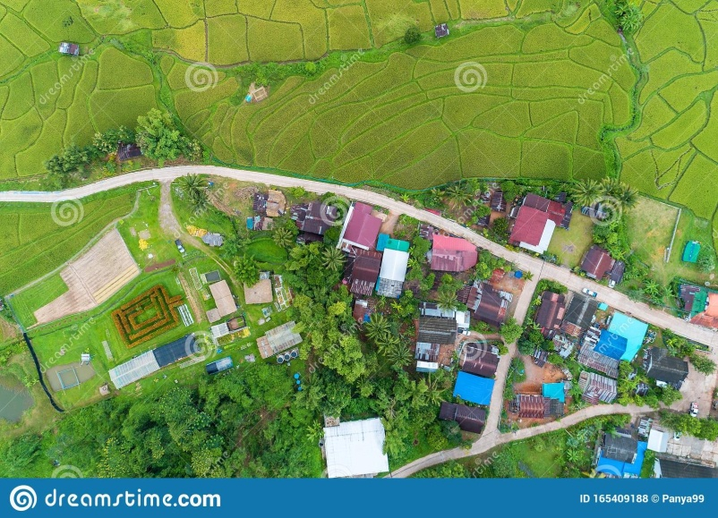

Fig.1: A satellite image example

## 1.1. Objective of the Project

Roads are important curvilinear object as they are a used in urban planning, emergency response, route planning etc. High resolution satellite images have become easily available, this has motivated researchers for searching advanced methods for object detection and extraction from satellite images . Automatic road detection from satellite images has now become an important topic in photogrammetry with the advances in remote sensing technology. In this paper, a method for road detection and extraction of satellite images has been introduced. The aim of this paper is to discover the potential of high resolution satellite images for detecting and extracting the road network in a robust manner.

## 1.2. Brief Description of Project

We will have a front end where one need to create an account by giving email and a password pr those who are already registered just have login and they will open a dashboard after login, where the user will see two option for road extraction one using K-means algorithm and another using Ostu’s method.

* **Ostu’s Method:** In this method, the input image is first preprocessed. After that a threshold is computed by Otsu's method . Using this threshold, the gray image is converted into binary image and it contains only black and white pixels. After that, the image is processed by morphological operators and thus a finer road network is extracted.
* **K-Means Algorithm:** It is an unsupervised clustering algorithm used to segment the interest area from the background. It clusters, or partitions the given data into K-clusters or parts based on the K-centroids that are chosen randomly. The algorithm is used when you have unlabeled data(i.e. data without defined categories or groups). The goal is to find certain groups based on some kind of similarity in the data with the number of groups represented by K.

## 

## 1.3. Tools and Platform

Python is the only programming language required for this project till now.

|  |  |
| --- | --- |
| **Library** | **Purpose** |
| pandas | Provides fast, flexible, and expressive data structures for structured data |
| matplotlib | Creates graphical visualisations |
| numpy | Provides arrays and other mathematical computations |
| OpenCV | process images and videos to identify objects, faces, or even handwriting of a human. |
| PIL | support for opening, [manipulating](https://en.wikipedia.org/wiki/Image_editing), and saving many different [image file formats](https://en.wikipedia.org/wiki/Image_file_formats) |
| Python Flex | Merging frontend with the backend |

Tab.1: List of essential Python libraries

## 

## 1.4. Project Organization

After our project topic was finalised in November 2020 , we had to look into existing and ongoing research. Since Python was not a part of our curriculum, we had to be well-versed with the language and the vast number of libraries it had to offer. Specifically, we had to learn about its applications in image processing. We researched many papers on image processing and to choose which algorithm is suitable

for our project of road detection from aerial images or images taken from drone.

Once comfortable with the basics, we moved on to choosing a 2 method for road detection that is suitable for our project. After implementing different algorithm for image processing, we have finalized our two methods.

The final step was to show our methods is showing the result as expected and to test that we compare the result with other algorithm of image processing.

**1.5. Timeline**

Timeline of our project is as follows:

Nov 2020: Literature Survey

Dec 2020: Knowledge Acquirement

Jan 2021- Feb 2021: Implementing Method 1

Mar 2021- April 2021: Implementing Method 2

April 2021- May 2021: Testing

May 2021: Merging with the frontend

May 2021- June 2021: Documentation

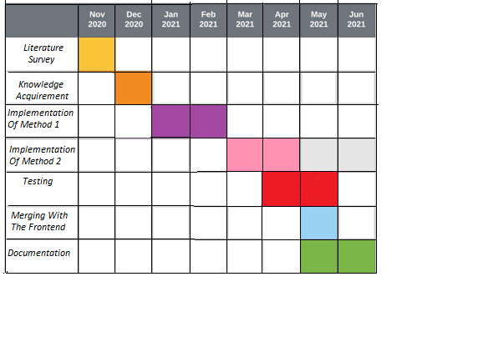

Fig. 2: Timeline

# 

# 2. Literature Survey

Satellite images often contain noises. Therefore, these images are preprocessed and enhanced before the extraction of objects. In image enhancement, digital images are altered and its visual interpretability is improved. Therefore, resultant images are more appropriate for analysis. Contrast enhancement is one of image enhancement technique. It improves the appearance of object and the brightness between object and its backgrounds[2].

Satellite images often contain several objects. Visual detection of these objects by humans is a slow, expensive and endless routine job. Therefore automatic object detection with the help of computers was developed. Object detection algorithms localise objects and annotates them with an object class label. Both tasks face many difficulties. On one hand, the detection method must be robust for different images or varying illumination conditions and it must account for changes in the object. On the other hand, these objects may appear of any size and at anywhere in an image. Hence for practical systems efficiency is very important factor [3]. The objects in satellite images are divided into three main categories of point, line and area type[4]. Linear features are described by arbitrary curves or straight lines. It can also used in transportation database, city planning, military field and map updating [5]. Linear pattern recognition has many practical applications like road detection, river detection, railroads detection, plant root analysis, retinal vessel extraction etc. Automatic road detection from satellite images has now become an important topic in photogrammetry after the advances in remote sensing technology.

# 3. Concepts and problem analysis

## 3.1. Python for Image Processing

Image processing means processing the image and this may include many different techniques until we reach our goal.The final output can be either in the form of an image or a corresponding feature of that image.

An image can be represented as a 2D function F(x,y) where x and y are spatial coordinates. The amplitude of F at a particular value of x,y is known as the intensity of an image at that point. If x,y, and the amplitude value is finite then we call it a digital image. It is an array of pixels arranged in columns and rows. Pixels are the elements of an image that contain information about intensity and color. An image can also be represented in 3D where x,y, and z become spatial coordinates. Pixels are arranged in the form of a matrix. This is known as an RGB image[6].There are various types of images:

* RGB image: It contains three layers of 2D image, these layers are Red, Green, and Blue channels.
* Grayscale image: These images contain shades of black and white and contain only a single channel.

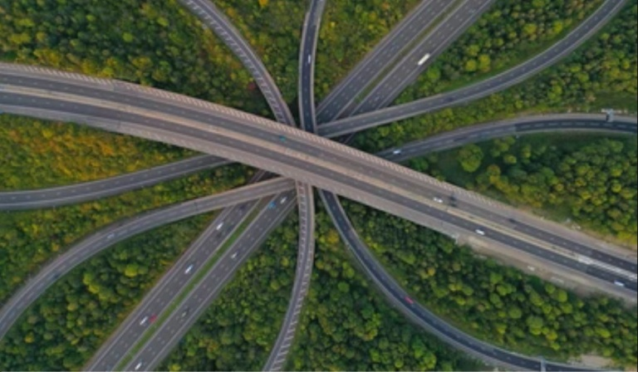

Fig.3: A RGB image example

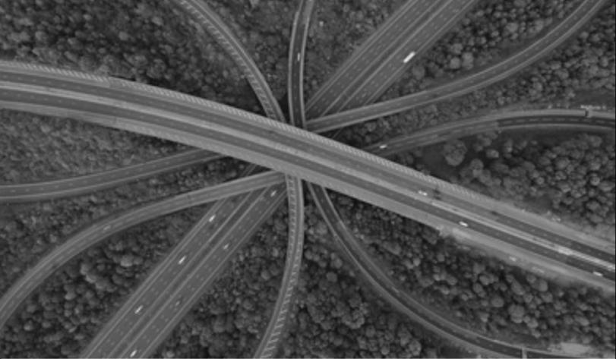

Fig.4: A Grayscale image example

## 3.2. Morphological Image Processing

Morphological transformations are some simple operations based on the image shape. It is normally performed on binary images. It needs two inputs, one is our original image, second one is called **structuring element** or **kernel** which decides the nature of operation. Two basic morphological operators are Erosion and Dilation. Then its variant forms like Opening, Closing.

* **Erosion:**The basic idea of erosion is just like soil erosion only, it erodes away the boundaries of foreground object. The kernel slides through the image (as in 2D convolution). A pixel in the original image (either 1 or 0) will be considered 1 only if all the pixels under the kernel is 1, otherwise it is eroded (made to zero).So what happens is that, all the pixels near boundary will be discarded depending upon the size of kernel. So the thickness or size of the foreground object decreases or simply white region decreases in the image. It is useful for removing small white noises (as we have seen in colourspace chapter), detach two connected objects etc[7].

 

Fig.5a:Input image Fig.5b:Output Image

* **Dilation:** It is just opposite of erosion. Here, a pixel element is ‘1’ if atleast one pixel under the kernel is ‘1’. So it increases the white region in the image or size of foreground object increases. Normally, in cases like noise removal, erosion is followed by dilation. Because, erosion removes white noises, but it also shrinks our object. So we dilate it. Since noise is gone, they won’t come back, but our object area increases. It is also useful in joining broken parts of an object[7].

 

Fig.6a:Input image Fig.6b:Output Image

* **Opening:** It is just another name of **erosion followed by dilation**. It is useful in removing noise, as we explained above. Here we use the function, **cv2.morphologyEx()[7].**



Fig.7: Input and output image

* **Closing:** It is reverse of Opening, Dilation followed by Erosion. It is useful in closing small holes inside the foreground objects, or small black points on the object[7].



Fig.8: Input and output image

**3.3. K-Means Algorithm for Image Processing**

[8] K-Means algorithm is an unsupervised clustering algorithm that classifies the input data points into multiple classes based on their inherent distance from each other. The algorithm assumes that the data features form a vector space and tries to find natural clustering in them. The points are clustered around centroids µi∀i = 1 . . . k which are obtained by minimizing the objective

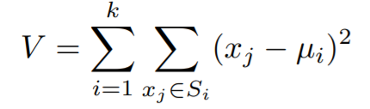 (1)

where there are k clusters Si , i = 1, 2, . . . , k and µi is the centroid or mean point of all the points xj ∈ Si

As a part of this project, an iterative version of the algorithm was implemented. The algorithm takes a 2 dimensional image as input. Various steps in the algorithm are as follows:

1. Compute the intensity distribution(also called the histogram) of the intensities.
2. Initialize the centroids with k random intensities.
3. Repeat the following steps until the cluster labels of the image does not change anymore.
4. Cluster the points based on distance of their intensities from the centroid intensities.

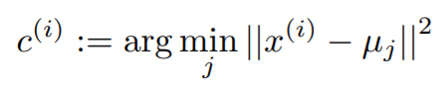 (2)

1. Compute the new centroid for each of the clusters.

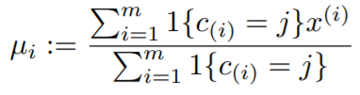 (3)

where k is a parameter of the algorithm (the number of clusters to be found), i iterates over the all the intensities, j iterates over all the centroids and µi are the centroid intensities. Example:

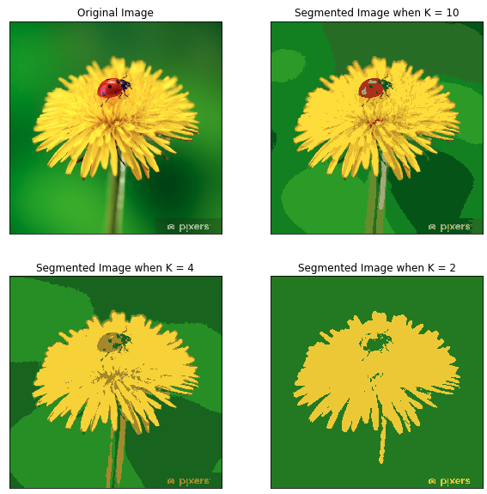

Fig. 9: Example of K-means image segmentation

## 

## 4. Design and Methodology

In this paper, Two methods has been proposed for detecting and extracting the road network from high resolution satellite images.

## 4.1. Method 1:

In this method, the input image is first preprocessed. After that a threshold is computed by Otsu's method [9]. Using this threshold, the gray image is converted into binary image and it contains only black and white pixels. Connected component analysis is then performed. After that, the image is processed by morphological operators and thus a finer road network is extracted.

**4.1.1. Image Preprocessing**

First of all, preprocessing is performed on the image. This step removes the noise from the image and enhances the contrast of the image. Preprocessing of the image has following steps:

**4.1.1.1. Grayscale conversion**

Colored images have three independent channels: red, green and blue. This increases the cost, processing time and complexity of the image. Grayscale images are single channel images on which contrast, shape, edges, etc can be studied without using color channels. Therefore the coloured images are converted into grayscale images.

* + - 1. **Histogram equalization**

Histogram equalization is a technique which remaps the input image pixels so that almost uniform histogram may be achieved. It helps in enhancing the contrast of the image. It is applied on the grayscale image.

**4.1.2. Binary image conversion**

**4.1.2.1 Selection of threshold**

Otsu's method of image segmentation is used for threshold selection. Otsu's method was given by N. Otsu in 1979. Otsu's algorithm selects threshold automatically. It is effective, fast, simple and stable. In Otsu's algorithm, a global threshold is computed which is later used to convert image into binary image. This global threshold is a positive scalar.

**4.1.2.2 Binarization**

After threshold selection, image is converted into another image where all pixel values which are greater than the threshold are replaced by 1 and rest pixel values are replaced by 0. As a result of this step, a black and white image is formed.

**3.4 Morphological operation**

After connected component analysis, the extracted roads still contain some holes and noises. This is so because connected component sometimes cannot identify small ground objects like building, lanes, vehicles, etc. To eliminate them and improve the accuracy of the results, the extracted results are processed by the various operations of mathematical morphology like opening, closing, dilation and erosion. Matheron and Serra introduced method of mathematical morphology by in 1964. Basic idea of this method is the application of mathematical morphology for image processing and analysis. Morphology is an approach in which objects and object features are identified through their shape [10].

* **Opening operation:**This operation is a process of erosion followed by dilation. Same structuring element is used for both erosion and dilation
* **Closing operation:** This operation is a process of erosion followed by dilation. Same structuring element is used for both erosion and dilation

## 4.2. Method 2

Clustering is a technique of grouping data together with similar characteristics in order to identify groups. A centroid is a data point at the center of a cluster [11]. K-means clustering finds clusters such that objects within each cluster are as close to each other as possible, and as far from objects in other clusters as possible. K-means clustering requires you to specify the number of clusters to be partitioned and a distance metric to specify how close two objects are to each other. We used K-Means to cluster the objects into clusters using the Euclidean distance metric and to segment the image in various clusters.

**4.2.1. Image Processing**

First, the image is read in and converted to an RGB image. Now, the data needs to be prepared for K-means clustering. The image is a 3-dimensional shape but to apply k-means clustering on it we need to reshape it to a 2-dimensional array.

**4.2.2. Image Segmentation**

Here, k refers to the number of clusters.

1. Choose the number of clusters to be found, which is k.
2. Randomly assign the data points to any of the k clusters.
3. Then calculate the centroids of the clusters.
4. Calculate the distance of the data points from the centroids of each of the clusters.
5. Depending on the distance of each data point from the cluster, reassign the data points to the nearest clusters.
6. Again calculate the new cluster center.
7. Repeat steps 4,5 and 6 till data points don’t change the clusters, or till the assigned number of iterations is reached.

Taking k=2, the K-means algorithm will identify 2 clusters in the image. If the value of k is increased, the image becomes clearer and distinct because the K-means algorithm can classify more classes/cluster of colors. K-means clustering works well when we have a small dataset. It can segment objects in images and also give better results.

**4.2.3. Thresholding**

The segmented image is then converted to a grayscale image and a threshold value is defined. Then, for each pixel of the gray scale image, if its value is lesser than the threshold, then we assign to it the value 0 (black). Otherwise, we assign to it the value 255 (white). The THRESH_BINARY function transforms a grayscale image to a binary image according to the formula:



where T(x,y) is a threshold calculated individually for each pixel [12]. This function takes the following parameters:

|  |  |
| --- | --- |
| src | Source 8-bit single-channel image. |
| dst | Destination image of the same size and the same type as src. |
| maxValue | Non-zero value assigned to the pixels for which the condition is satisfied |
| adaptiveMethod | Adaptive thresholding algorithm to use. |
| thresholdType | Thresholding type that must be either [THRESH_BINARY](https://docs.opencv.org/3.4/d7/d1b/group__imgproc__misc.html#ggaa9e58d2860d4afa658ef70a9b1115576a147222a96556ebc1d948b372bcd7ac59) or [THRESH_BINARY_INV](https://docs.opencv.org/3.4/d7/d1b/group__imgproc__misc.html#ggaa9e58d2860d4afa658ef70a9b1115576a19120b1a11d8067576cc24f4d2f03754) |
| blockSize | Size of a pixel neighborhood that is used to calculate a threshold value for the pixel: 3, 5, 7, and so on. |
| C | Constant subtracted from the mean or weighted mean (usually positive). |

Tab. 2: Parameters of THRESH _BINARY Function

# 5. Sample Code

**5.1. Sample Code and Output For Method 1**

## 5.1.1. Conversion of Image Into Grayscale Image

img1 = cv2.imread(r"C:\Users\Laptop\Desktop\Final year\Data_Set\Test1.jpg",-1)

plt.imshow(cv2.cvtColor(img1, cv2.COLOR_BGR2RGB))

plt.axis("on")

plt.title("Orginal Image")

plt.show()

imgGray = cv2.cvtColor(img1, cv2.COLOR_BGR2GRAY)

cv2.imwrite(r"C:\Users\Laptop\Desktop\Final year\final1.jpg",imgGray)

plt.imshow(cv2.cvtColor(imgGray, cv2.COLOR_BGR2RGB))

plt.axis("on")

plt.title("Grayscale image")

plt.show()

## 5.1.2. Applying Histogram Equilisation

equ = cv2.equalizeHist(imgGray) #final2= np.hstack((img2,equ)) #stacking images side-by-side

cv2.imwrite(r"C:\Users\Laptop\Desktop\Final year\final2.png",equ)

plt.imshow(cv2.cvtColor(equ, cv2.COLOR_BGR2RGB))

plt.axis("on")

plt.title("Applying histogram equilisation ")

plt.show()

### 

### 5.1.3. Applying Ostu’s method

final4,thresh1 = cv2.threshold(equ, 0, 255, cv2.THRESH_BINARY +  cv2.THRESH_OTSU)  #Syntax: cv2.threshold(source, thresholdValue, maxVal, thresholdingTechnique)

cv2.imwrite(r"C:\Users\Laptop\Desktop\Final year\final4.png",thresh1)

plt.imshow(cv2.cvtColor(thresh1, cv2.COLOR_BGR2RGB))

plt.axis("on")

plt.title("Applying otsu's method ")

plt.show()

**5.1.4. Applying Morphological operation**

kernel = np.ones((5,5),np.uint8)

opening = cv2.morphologyEx(thresh1, cv2.MORPH_OPEN, kernel)

plt.imshow(cv2.cvtColor(opening, cv2.COLOR_BGR2RGB))

plt.axis("on")

plt.title("Output Image")

plt.show()

#cv2.imwrite(r"C:\Users\Laptop\Desktop\Final year\Output 1a.png",closing)

cv2.imwrite(r"C:\Users\Laptop\Desktop\Final year\Data_Set\Output 1.png",opening)

### 

### 5.1.5 Visualisations and Output

Visualisations are an important aspect of any data science or machine learning project. Apart from providing a simple solution on grounds of statistics, it is our responsibility to arm the user with tools to dig deeper.

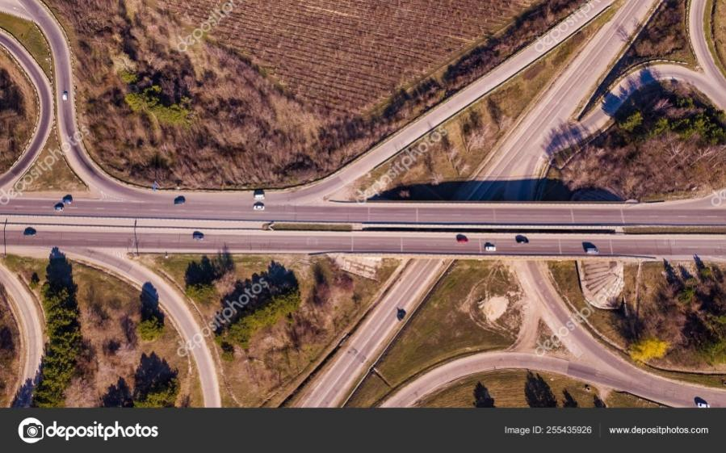

Fig. 10: Input Image

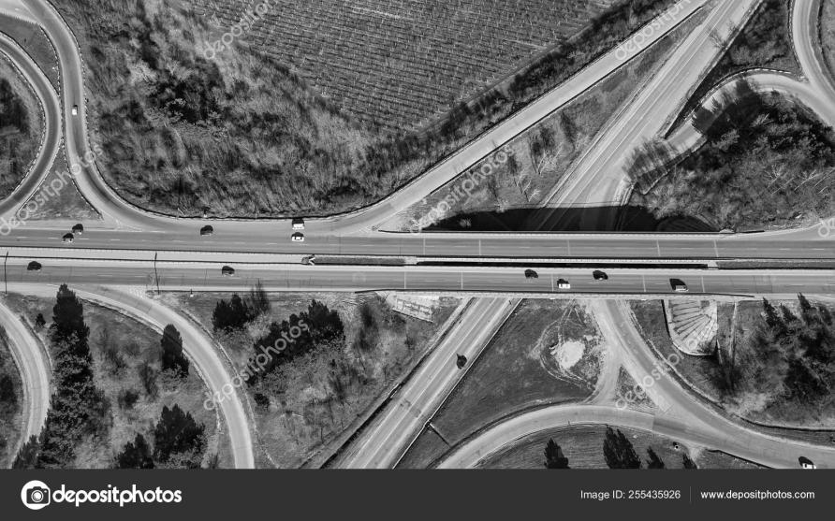

Fig. 11: Gray Scale Image

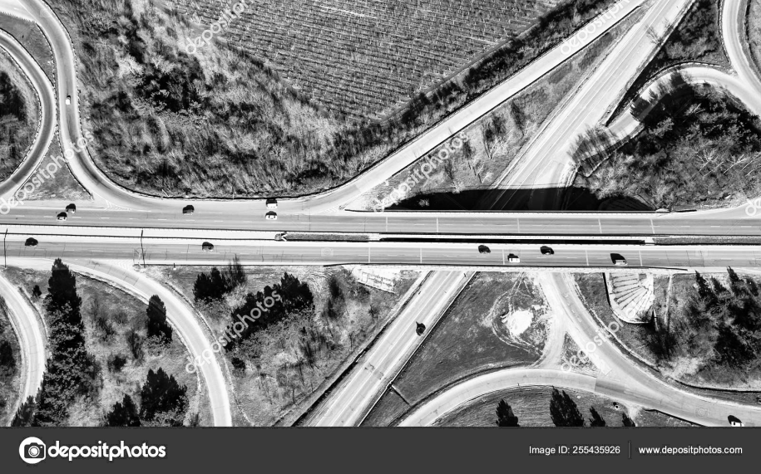

Fig. 12: Image After Applying Histogram Equilisation

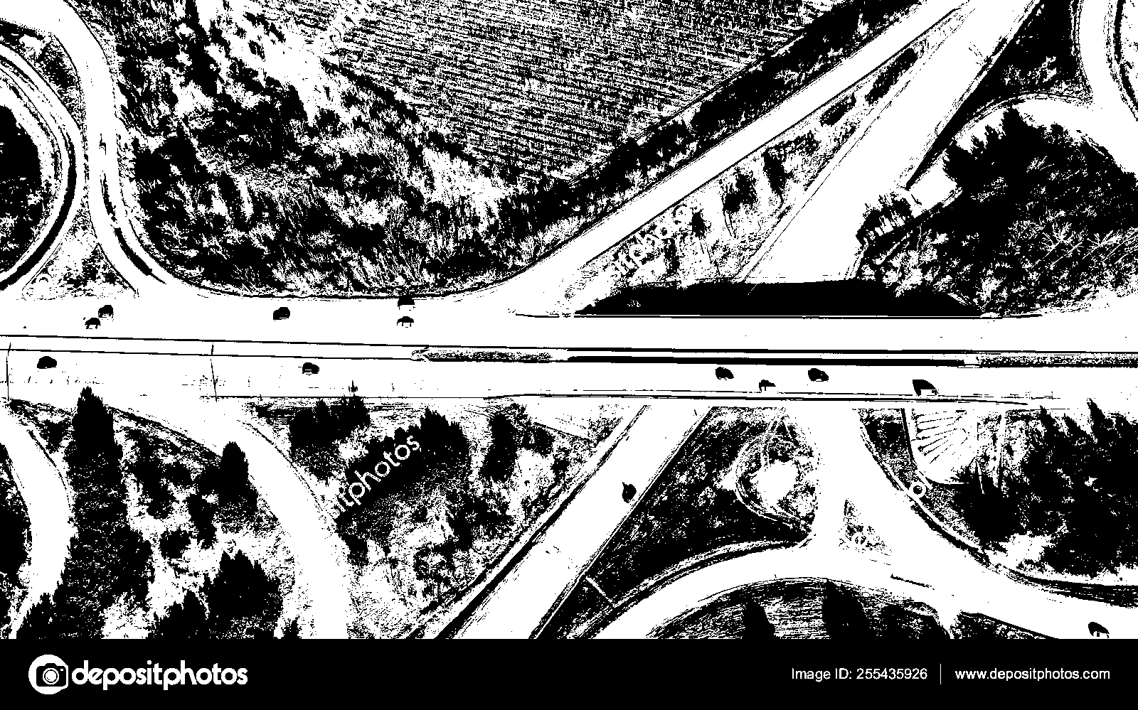

Fig. 13: Image after Binary Conversion (Ostu’s Method)

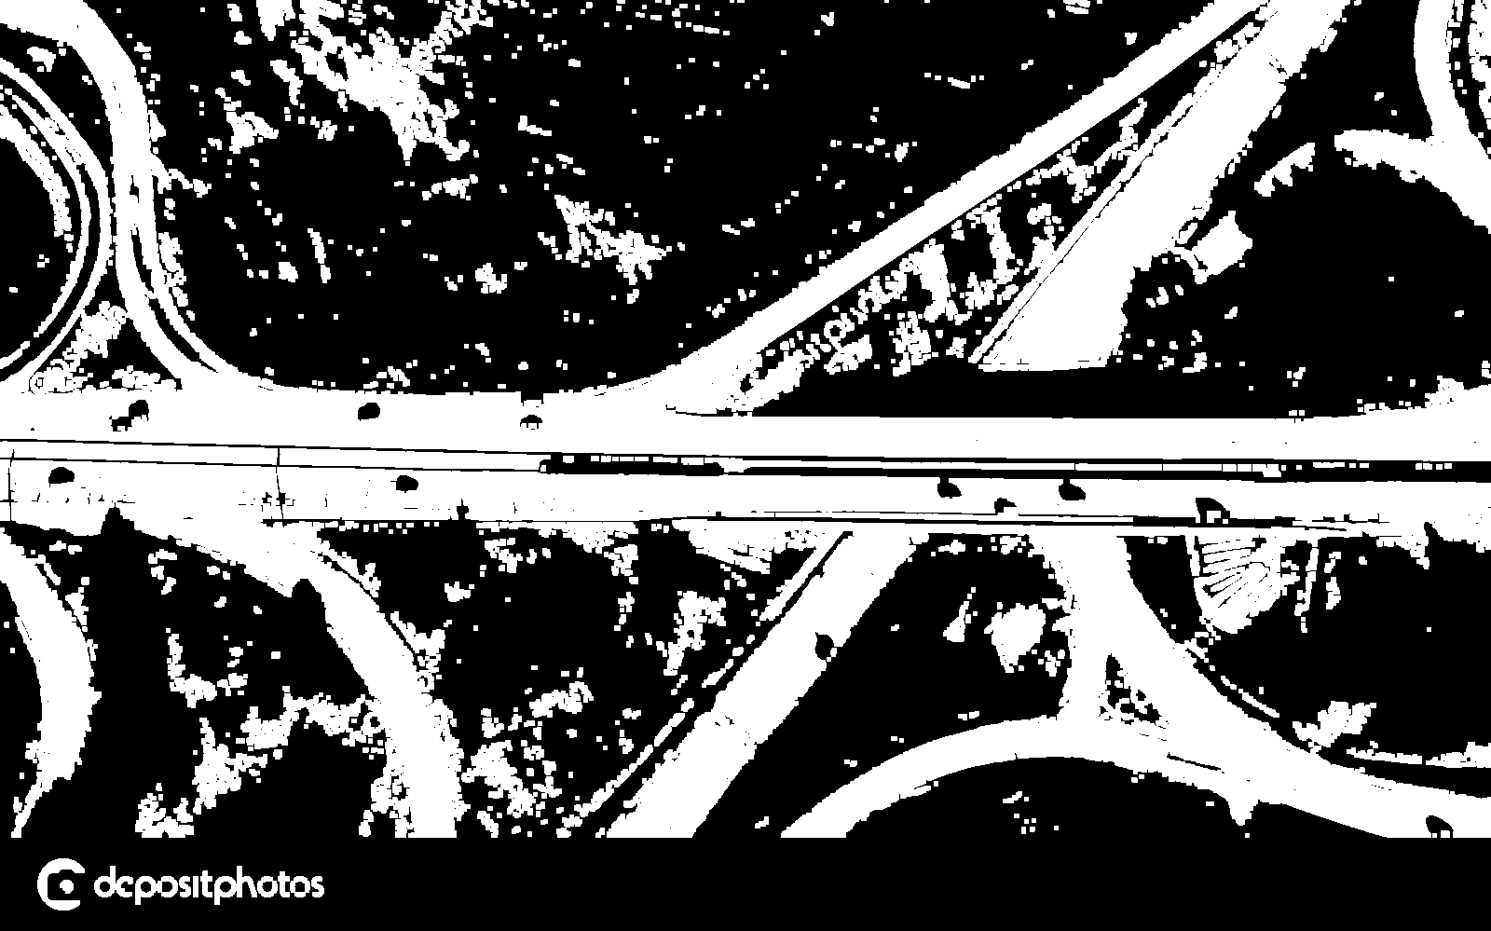

Fig. 14: Final Output Image

**5.2. Sample Code and Output For Method 2**

## 5.2.1. Conversion of Image into 2D RGB Image

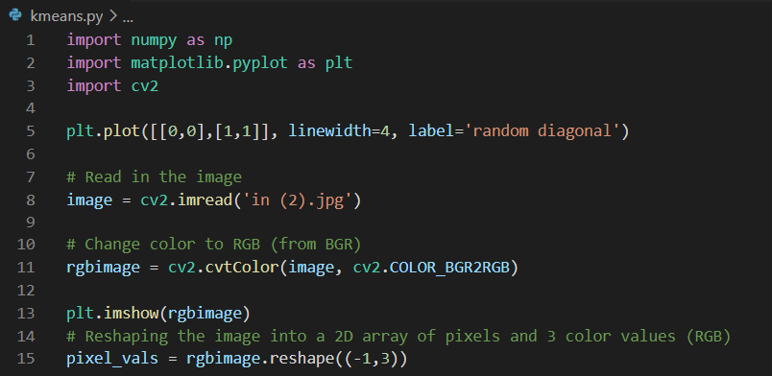

## 5.2.2. Applying K-Means Algorithm

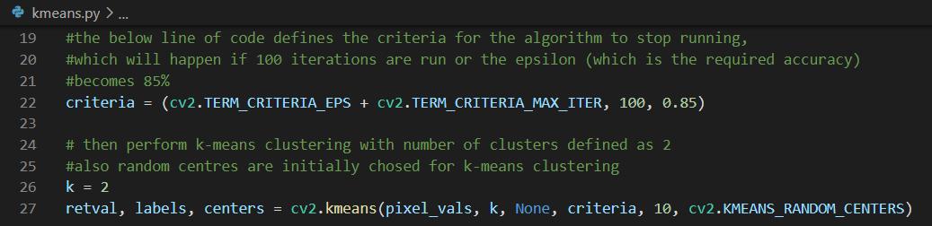

## 5.2.3. Binary Thresholding the Image

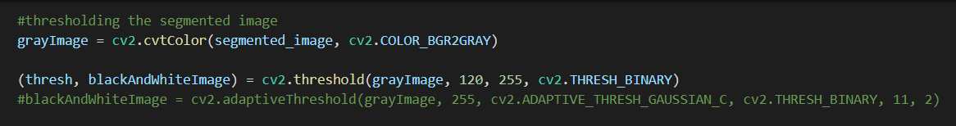

### 5.2.4 Visualisations and Output

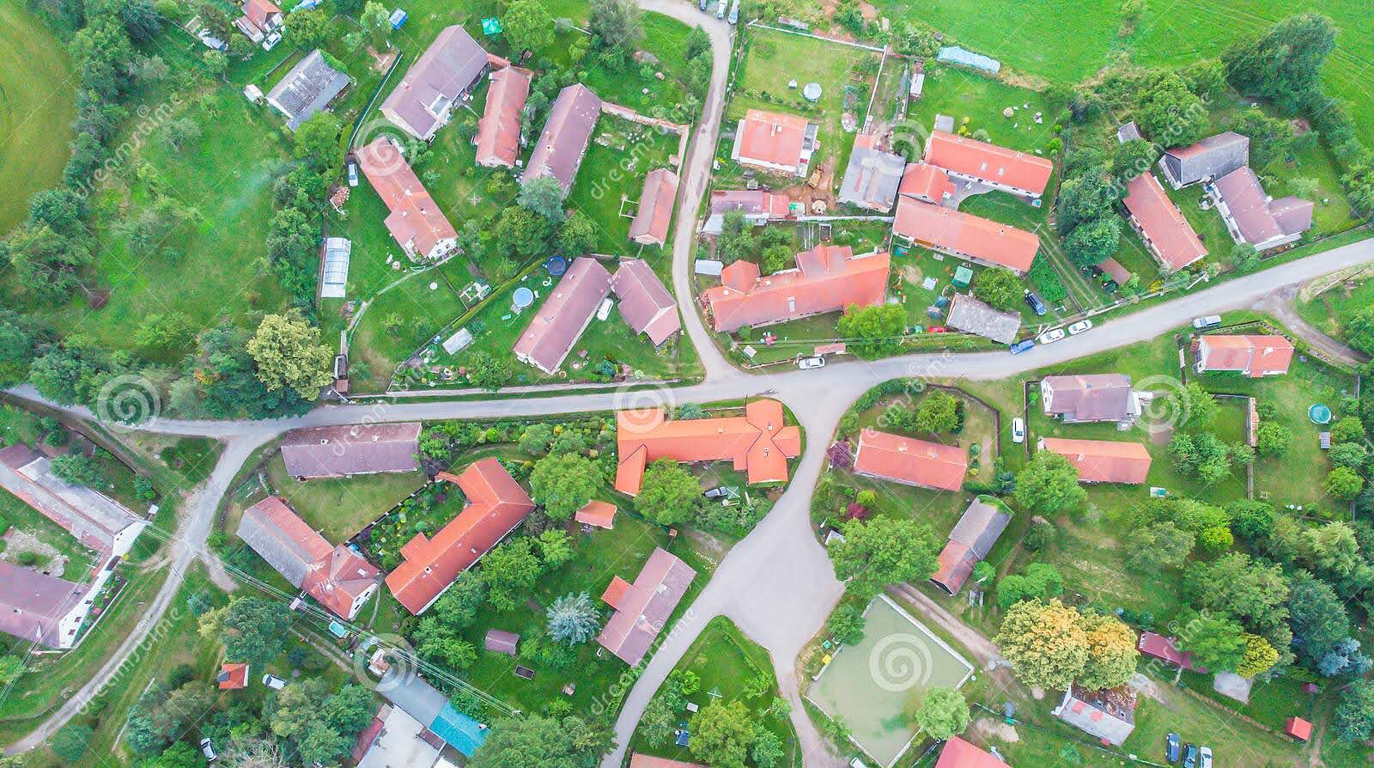

Fig. 15: Input Image

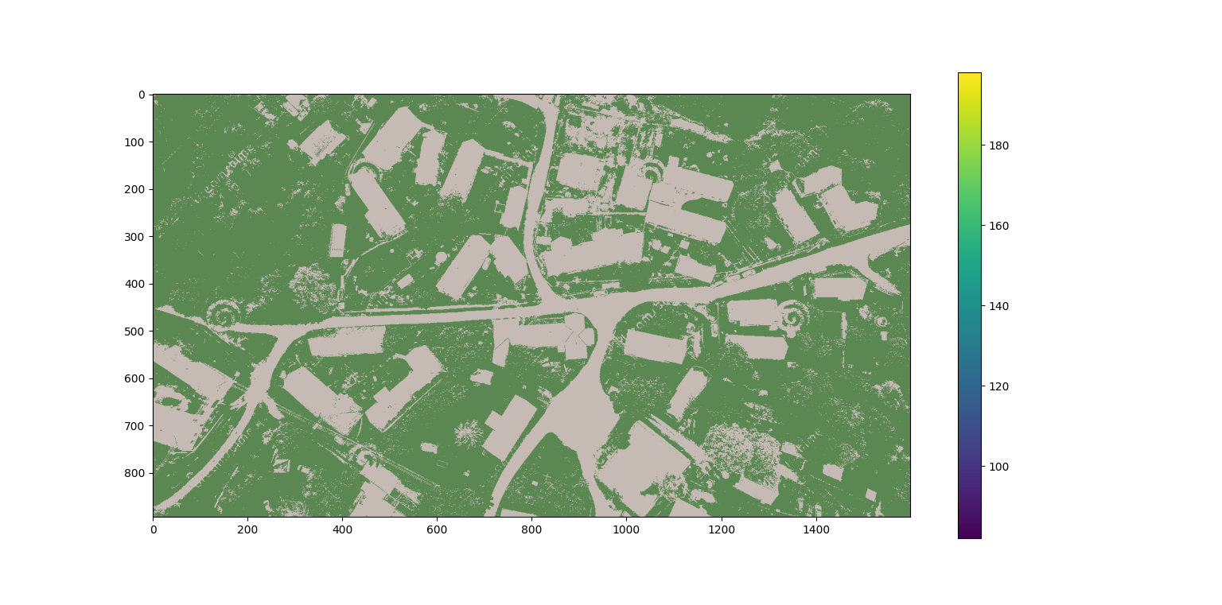

Fig. 16: Segmented Image with Colour bar

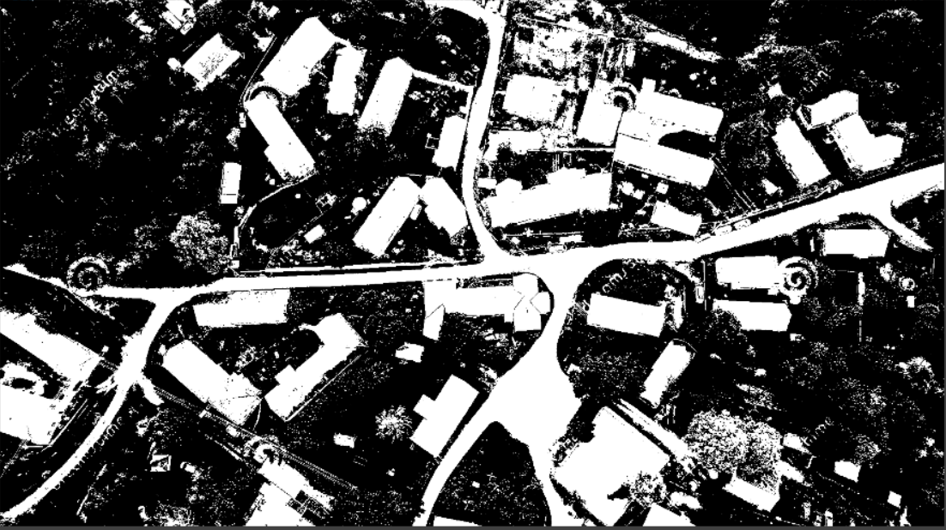

Fig. 17: Binary Output Image

# 6. Testing, Results and Discussion

**6.1. Method 1**

**6.1.1 Result**

The results of proposed method of road identification and extraction are shown in section 5.1.5. The proposed method has been applied on high resolution satellite images. Figure 10 shows the original colored image. Figure 11 shows the image obtained after the grayscale conversion of the original image. Figure 12 shows the image obtained after histogram equalization. In this difference between foreground objects and background has been enhanced. Figure 13 shows the binary conversion of image. In this, road areas have been converted to white pixels but there are some other objects also which have been converted to white pixels but they do not belong to road. Figure 14 shows the result of the morphological operations which are applied on the image. Small isolated pixels have been removed and road network has been enlarged to broad lines so that it can be identified well. After the extraction, as figure 14 shows, most of the road pixels have been obtained. Extra objects which are identified around the road area have been removed. Some areas that are connected to road network could not been removed. But most areas of road have been extracted.

**6.1.2 Testing**

We Tested the first method with other algorithms [13] of image processing to see if our algorithm is working properly.

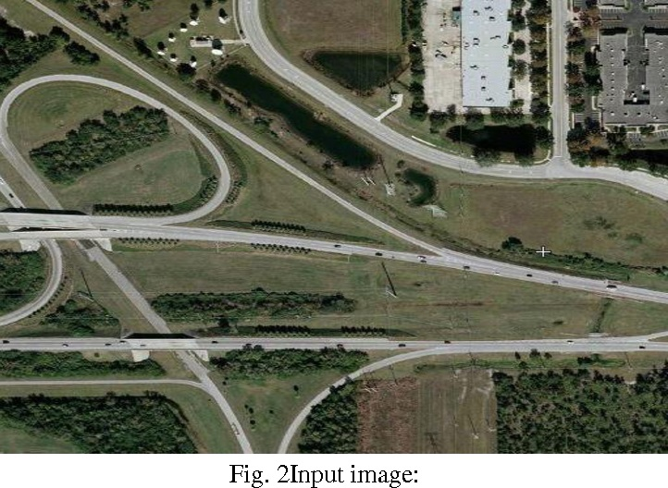

Fig. 18: Input Image

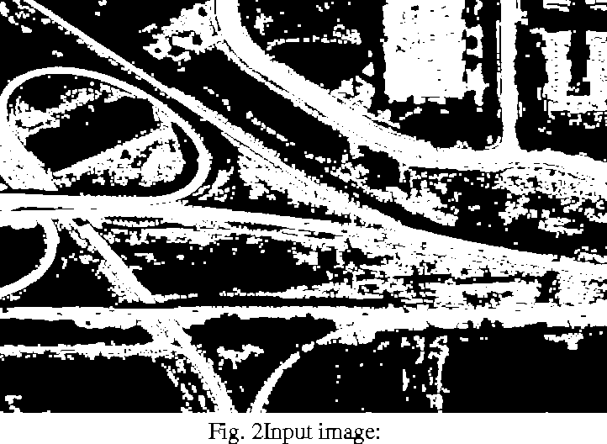

Fig. 19: Output Image

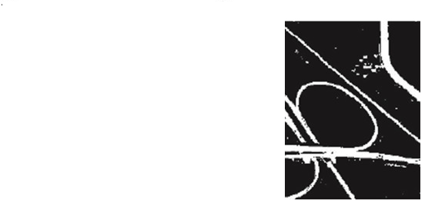

Fig. 20: Expected Output

**6.1.3 Discussion**

The testing of proposed method of road identification and extraction are shown in section 6.1.2. We see that in figure 19 we can detect the road and extra objects which are identified around the road area have been removed. We then compare with expected output i.e. figure 20 and found that some areas that are connected to road network could not been removed. We have created a database for these algorithm and tested this algorithm with many images. Some of the testing are as follows:

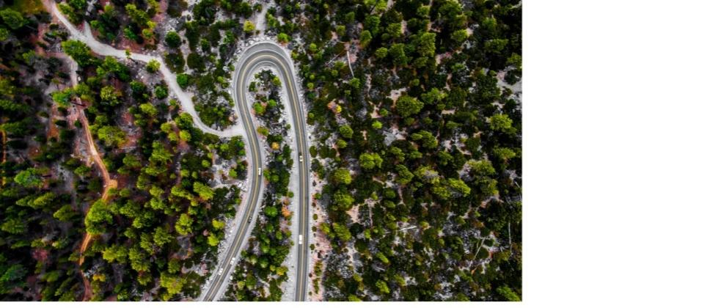 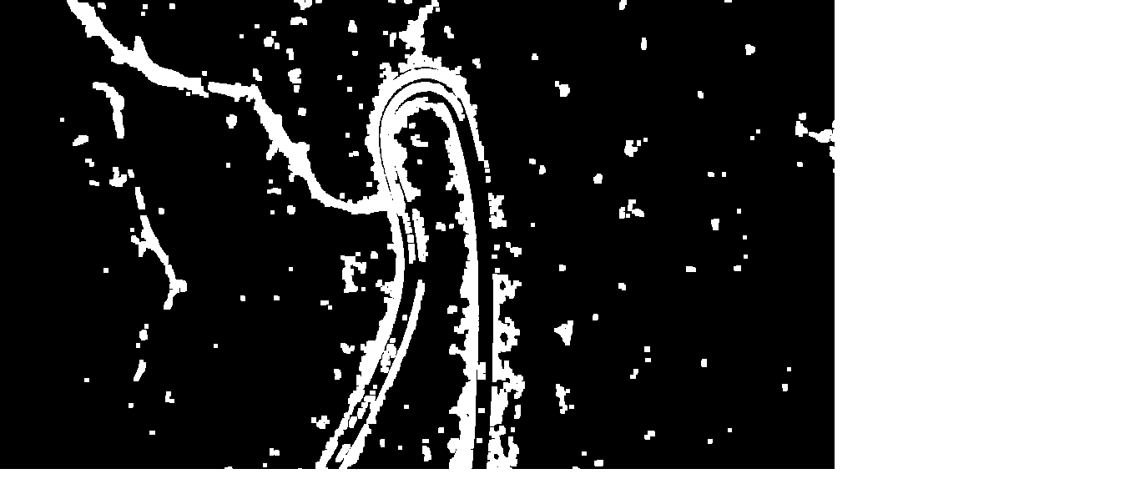

Fig. 21: Input Image Fig. 22: Output Image

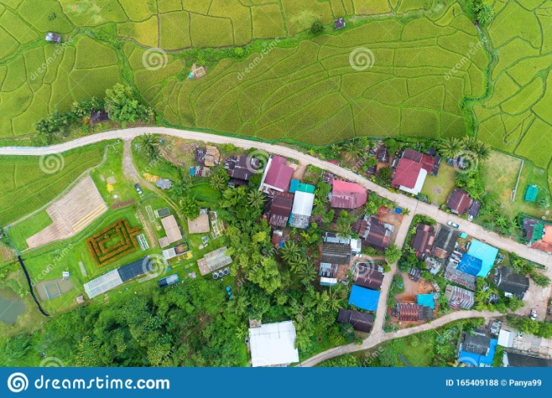 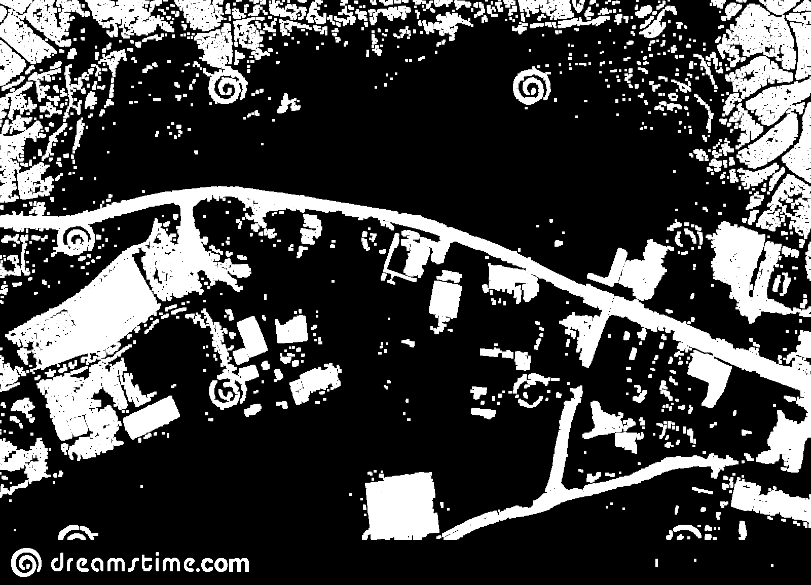

Fig. 23: Input Image Fig. 24: Output Image

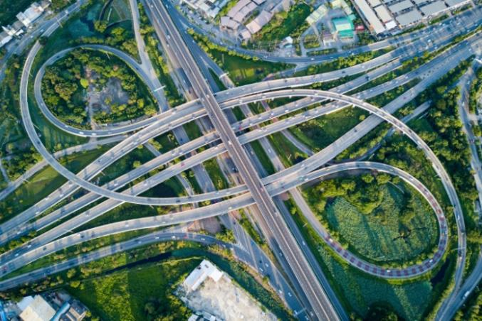 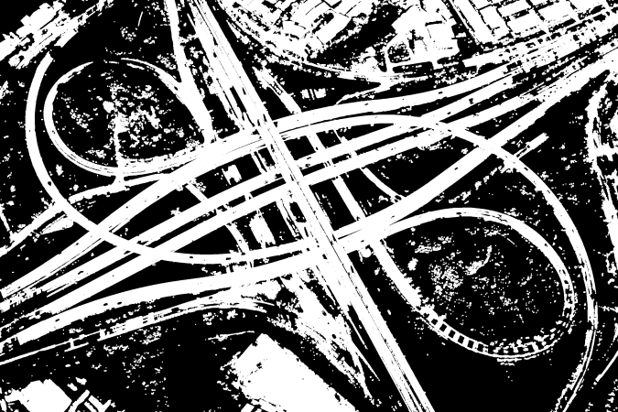

Fig. 25: Input Image Fig. 26: Output Image

**6.2. Method 2**

**6.2.1 Result**

The results of proposed method of road identification and extraction are shown in section 5.2.4. The proposed method has been applied on high resolution aerial images taken from drones and satellites. Figure 15 shows the original colored image. After the original image has been converted from a BGR image to an RGB 2 dimensional array of pixels, it is segmented using K-means clustering algorithm, which is shown in Figure 16. The image is segmented into two colour clusters. Figure 17 shows the binary conversion of the colour segmented image using the thresholding function in Python.

**6.2.2 Testing**

For the second method, the testing done is to compare the results against a manually plotted, high quality reference model, such as the one shown in figure 27. The method for evaluating the results of road extraction can be done by completeness, correctness and quality measure evaluation [14]. The quality of output depends on how much part of our derived output matches with the reference data.

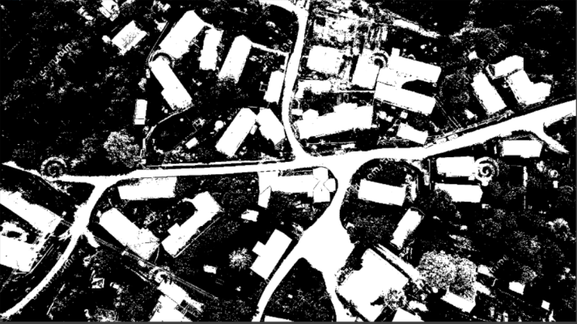 

Fig. 27: Comparison with Reference Image

**Completeness:** The completeness is the percentage of the reference data which is explained by the extracted data, i.e., the percentage of the reference data which lies within the buffer around the extracted data. The optimum value for completeness is 1. It is given by the formula:

Completeness = Length of matched reference

Length of reference

≈ d TP [TP= True Positive

TP + FN FN= False Negative]

Completeness ϵ [0; 1]

**Correctness:** The correctness represents the percentage of correctly extracted road data, i.e., the percentage of the extracted data which lie within the buffer around the reference data. The optimum value for correctness is 1. It’s formula is given by:

Correctness = Length of matched extraction

Length of extraction

≈ TP

TP + FP [FP=False Positive]

Correctness ϵ [0; 1]

**Quality:** The quality is a measure of the “goodness” of the final result. It takes into account the completeness of the extracted data well as its correctness. The optimum value for quality is 1. It’s formula is given by:

Quality = Length of matched extraction

qq

≈ TP

TP +FP+ FN [FN=False Negative]

Quality ϵ [0; 1]

qq = length of extracted data + length of unmatched reference

We have tested the various images for road extraction, the result of ten test images in terms of completeness, correctness and quality is given in the following table.

|  |  |  |  |
| --- | --- | --- | --- |
| **Image** | **Completeness** | **Correctness** | **Quality** |
| 1 | 0.934682 | 0.79289 | 0.751222 |
| 2 | 0.912124 | 0.683685 | 0.641435 |
| 3 | 0.884832 | 0.789277 | 0.715748 |
| 4 | 0.783529 | 0.772095 | 0.636354 |
| 5 | 0.734900 | 0.848870 | 0.649871 |
| 6 | 0.621824 | 0.570012 | 0.423276 |
| 7 | 0.580309 | 0.722598 | 0.479582 |
| 8 | 0.608722 | 0.723162 | 0.493681 |
| 9 | 0.595211 | 0.346973 | 0.280730 |
| 10 | 0.677801 | 0.666831 | 0.506331 |

Tab. 3: Evaluation Results

**6.1.3 Discussion**

Thus, it is observed that this method of road extraction can extract roads very rapidly and gives satisfactory results. But urban area with large number of complicated buildings and area with darker road needs to be researched further, as observed in figure 27. We have created a database for these algorithms and tested this algorithm with many images. Some of the testings done are as follows:

|  |  |  |
| --- | --- | --- |
| Fig. 28: Input Image | Fig. 29: Output Image | Fig. 30: Reference Image |
| Fig. 31: Input Image | Fig. 32: Output Image | Fig. 33: Reference Image |
| Fig. 34: Input Image | Fig. 35: Output Image | Fig. 36: Reference Image |

# 7. Conclusion and Future Work

In this paper, road detection and extraction methods has been proposed and implemented for high resolution satellite images. First method is based on Otsu's segmentation method and morphological operations. In proposed method, high resolution satellite image is converted to grayscale image, contrast of image was enhanced by histogram equalization. A threshold was selected by using Otsu's method and using this threshold, image was converted into binary image.. After that, morphological operations were used to refine the image. Then, extracted road network has been found. There are some limitations in this approach. The areas connected to road network could not been removed. To deal with this limitation, if width of objects could be calculated then this limitation could be removed by applying a threshold on width of objects. Second method is based on K-means clustering algorithm. K-means is the clustering algorithm used to determine the natural spectral groupings present in a data set. This accepts from analyst the number of clusters to be located in the data. The algorithm then arbitrarily seeds or locates, that number of cluster centers in multidimensional measurement space [15]. Each pixel in the image is then assigned to the cluster whose arbitrary mean vector is closest. The procedure continues until there is no significant change in the location of class mean vectors between successive iterations of the algorithms. Using color based image segmentation; it is possible to reduce the computational cost avoiding feature calculation for every pixel in the image. Although the color is not frequently used for image segmentation, it gives a high discriminative power of regions present in the image. This kind of image segmentation may be used for mapping the changes in land use land cover taken over temporal period in general.

# Bibliography

[1] Singh, P.P., Garg, R.D., 2013. Automatic Road Extraction from High Resolution Satellite Image using Adaptive Global Thresholding and Morphological Operations. Journal of Indian Socociety Remote Sensing 41, 631–640. [https://doi.org/10. 1007/s12524-012-0241-4](https://doi.org/10.%201007/s12524-012-0241-4)

[2] Chalekar, K., Yengantiwar, T., 2014. Review Paper on Image Contrast Enhancement Techniques. International Journal of Advanced Research in Computer Engineering & Technology (IJARCET) 3, 909–911.

[3] Kapoor, D., Kumar, M., Pant, P., 2014. Automated Object Recognition From High Resolution Satellite Images : A Review. International Journal of Advanced Research in Computer Engineering & Technology (IJARCET) 3, 4277–4282.

[4] Mohammadzadeh, A., ValadanZoej, M.J., Tavakoli, A., 2007. Automatic Class Mean Calculation of Road Surface From Ikonos Images Using Fuzzy Logic and Particle Swarm Optimization, in: Photogrammetric Image Analysis. ISPRS, Munich, pp. 119–124.

[5] Wang, J., Qin, Q., Gao, Z., Zhao, J., Ye, X., 2016. A New Approach to Urban Road Extraction Using High-Resolution Aerial Image. ISPRS International Journal of Geo-Information 5, 1–12. <https://doi.org/10.3390/ijgi5070114>

[6] Image Processing in Python: <https://neptune.ai/blog/image-processing-in-python-algorithms-tools-and-methods-you-should-know>

[7]Morphological Analysis:

https://opencv24-python-tutorials.readthedocs.io/en/latest/py_tutorials/py_imgproc/py_morphological_ops/py_morphological_ops.html

[8]Suman Tatiraju, Avi Mehta “Image Segmentation using kmeans clustering , EM and Normalized Cuts”, University Of California Irvine . Available from:

<https://www.dca.fee.unicamp.br/~leopini/DISCIPLINAS/IA369T-22014/Seminarios-entregues/Grupos-BigData/BigData-Gr-LuisPattam-paperdeapoio-3.pdf>

[9] Qu, Z., Zhang, L., 2010. Research on Image Segmentation Based on the Improved Otsu Algorithm, in: 2nd International Conference on Intelligent Human-Machine Systems and Cybernetics. Jiangsu, pp. 228–231. [https://doi.org/10.1109/IH MSC.2010.157](https://doi.org/10.1109/IH%20MSC.2010.157)

[10] Kaur, S., Ritika, 2013. Contrast Enhancement Techniques for Images – A Visual Analysis. International Journal of Computer Applications 64, 20–25.

[11] Using K-Means Clustering for Image Segmentation by [Cierra Andaur](https://cierra-andaur.medium.com/?source=post_page-----fe86c3b39bf4--------------------------------). Available from:

<https://blog.usejournal.com/using-k-means-clustering-for-image-segmentation-fe86c3b39bf4>

[12] OpenCV documentation available from:

<https://docs.opencv.org/4.5.2/d7/d4d/tutorial_py_thresholding.html>

[13]Comparing the output: https://www.sciencedirect.com/science/article/pii/S2095756416301076

[14] Road Extraction Using K-Means Clustering and Morphological Operations by Rohit Maurya, Dr. Shalini Singh, Dr. P.R Gupta, Manish Kumar Sharma, Centre for Development of Advance Computing. Available from:

<https://www.academia.edu/1638618/Road_extraction_using_K-Means_clustering_and_morphological_operations>

[15] Colour Based Image Segmentation Using K-Means Clustering by Anil Z Chitade and Dr. S.K. Katiyar, Department of civil Engineering, MANIT, Bhopal. Available from: https://www.researchgate.net/publication/50361273_Color_based_image_segmentation_using_K-means_clustering/fulltext/0f3197353829de221642f3ec/Color-based-image-segmentation-using-K-means-clustering.pdf